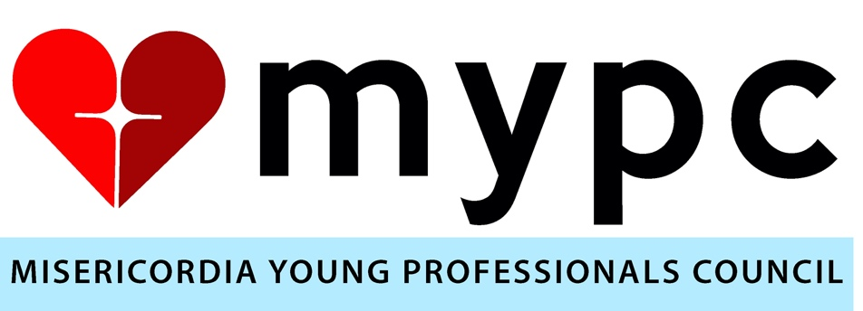

2024 Calendar
February 7th – Council Meeting 6:30-7:30 PM
February 21st – Red Heart Bash Kickoff Party
March 3rd – Brunch with Sister Rosemary & Lois Gates at Misericordia 11am-1pm
March 20th – Council Meeting 6:30 – 7:30 PM
April 12th – Red Heart Bash 7:00PM at The Walden
April 26th/27th – Misericordia Candy Days
May 29th – Council Meeting 6:00-7:00PM
June 20th – CILA BBQ 6:30 – 8:00 PM
TBD – Chicago Cubs Game with Misericordia Residents
TBD – MYPC Summer Party
August 21st – Council Meeting 6:00-7:00PM
September 8th – Misericordia Family Fest
October 24th – Volunteer Event at Misericordia Shannon Apartments
November 28th – Misericordia Bakery Volunteer Event
December 7th – Holiday Party

